Министерство образования Республики Беларусь

УО «Брестский государственный технический университет»

Кафедра ИИТ

Лабораторная работа №4

По дисциплине: “Алгоритмы и структуры данных”

Тема: «Работа с Python»Вариант №1

**Выполнил**:

студент 2 курса группы ПО-7 Белев С.В.

**Проверила:**

Дряпко А.В.

Брест 2021

**Постановка задачи:**

Выполнить задания согласно своему варианту.

**Вариант задания:**

Вариант 1.

**Код программы:**

from math import fabs as mod  
from random import randrange as rand  
  
  
def formula(a, b, c, k):  
 return mod((a ** 2 / b ** 2 + c ** 2 * a ** 2) / (a + b + c * (k - a / b ** 3)) + c + (k / b - k / a) * c)  
  
  
def T1():  
 var = []  
 for i in range(4):  
 var.append(int(input()))  
 print(formula(var[0], var[1], var[2], var[3]))  
  
  
def T2():  
 lst = []  
 for i in range(20):  
 lst.append(rand(0, 100, 1))  
 for i in range(len(lst)):  
 if lst[i] % 2 == 0:  
 print(lst[i])  
  
  
def T3():  
 lst = []  
 sum = 0  
 for i in range(10):  
 lst.append(rand(0, 15, 1))  
 for i in range(len(lst)):  
 if lst[i] / 10 >= 1:  
 sum = sum + lst[i]  
 print(sum)  
  
  
def T4():  
 lst = []  
 max = 0  
 for i in range(10):  
 lst.append(rand(0, 15, 1))  
 for i in range(len(lst)):  
 if lst[i] > max:  
 max = lst[i]  
 print(max)  
  
  
def T5():  
 from random import randrange as rand  
 my_number = rand(0, 10)  
 user_number = 10  
 while user_number >= my_number:  
 user_number = int(input())  
 print("You win!")  
  
  
def T6():  
 lst = []  
 max = 0  
 for i in range(10):  
 lst.append(str(rand(10000, 9999999999, 1)))  
 for i in range(len(lst)):  
 print(lst[i])  
  
  
def T7():  
 string = ""  
 for i in range(5):  
 string = string + chr(rand(1040, 1072))  
 print(string)  
  
  
def T8():  
 string = "Я каменщик, работаю 3 дня"  
 nstr = ""  
 for i in range(len(string)):  
 if (ord(string[i]) >= 48) and (ord(string[i]) <= 57):  
 nstr = nstr + string[i]  
 print(nstr)  
  
  
matr = [  
 [1, 2, 3, 4, 5, 6, 7, 8],  
 [8, 7, 6, 5, 4, 3, 2, 1],  
 [2, 3, 4, 5, 6, 7, 8, 9],  
 [9, 8, 7, 6, 5, 4, 3, 2],  
 [1, 3, 5, 7, 9, 7, 5, 3],  
 [3, 1, 5, 3, 2, 6, 5, 7],  
 [1, 7, 5, 9, 7, 3, 1, 5],  
 [2, 6, 3, 5, 1, 7, 3, 2]  
]  
  
  
def T9():  
 for i in range(8):  
 for k in range(8):  
 matr[i][k] = matr[i][k] ** 2  
 for i in range(8):  
 for k in range(8):  
 print(matr[i][k], end="\t")  
 print()  
  
  
def T10():  
 sum = [0, 0, 0, 0, 0, 0, 0, 0]  
 for i in range(8):  
 for k in range(8):  
 sum[i] = sum[i] + matr[i][k]  
 print(sum)  
  
  
def T11():  
 sum = [1, 8, 2, 9, 1, 3, 1, 2]  
 for i in range(8):  
 for k in range(1, 8):  
 sum[i] = sum[i] * matr[i][k]  
 print(sum)  
  
  
def T12():  
 for i in range(8):  
 for k in range(8):  
 matr[i][k] = matr[i][k] * (matr[i][k] % 2)  
 print(matr)  
  
  
def T13():  
 matrtemp = matr  
 delete = int(input())  
 matrtemp.pop(delete)  
 print(matrtemp)  
  
  
def T14():  
 matrtemp = matr  
 chng = []  
 for i in range(8):  
 chng.append(matrtemp[0][i])  
 matrtemp[0] = matrtemp[7]  
 matrtemp[7] = chng  
 print(matrtemp)  
  
  
def T15():  
 string = "!,!Ihate am !stonecutter? i -am working. forlk a 3 dayskiuiu!?.,"  
 stringres = ""  
 bl = "nobreak"  
 i = 0  
 words = string.split()  
 while i != len(words) - 1:  
 for i in range(len(words)):  
 bl = "nobreak"  
 for k in range(len(words[i])):  
 if words[i][k] == "!" or words[i][k] == "?" or words[i][k] == "." or words[i][k] == "," or words[i][  
 k] == ":" or words[i][k] == ";":  
 words[i] = words[i][:k] + words[i][k + 1:]  
 i -= 1  
 bl = "break"  
 break  
 if bl == "break":  
 break  
 for i in range(len(words)):  
 if len(words[i]) >= 5:  
 stringres += words[i]  
 stringres += " "  
 print(string)  
 print(stringres)  
  
  
def T16():  
 string = "Иванов;Иван;Иванович;23 года;Студент 3 курса;_Петров;Семен;Игоревич;22 года;Студент 2 курса"  
 Students = string.split("_")  
 Info = []  
 for i in range(len(Students)):  
 Info.append([0, ])  
 for i in range(len(Students)):  
 Info[i] = Students[i].split(";")  
 print("ФИО\t\t\t\t\t\t Категория\t\t\t Возраст")  
 for i in range(len(Students)):  
 print(Info[i][0], Info[i][1], Info[i][2], "\t", Info[i][4], "\t", Info[i][3])  
  
  
def T17():  
 string = "Иванов;Иван;Иванович;23 года;Студент 3 курса;_Петров;Семен;Игоревич;22 года;Студент 2 курса"  
 Students = string.split("_")  
 Info = []  
 for i in range(len(Students)):  
 Info.append([0, ])  
 for i in range(len(Students)):  
 Info[i] = Students[i].split(";")  
 print("ФИО\t\t\t\t\t\t Категория\t\t\t Возраст")  
 for i in range(len(Students)):  
 if Info[i][0] == "Петров":  
 print(Info[i][0], Info[i][1], Info[i][2], "\t", Info[i][4], "\t", Info[i][3])  
  
  
def T18():  
 string = "!,!Ihate am !stonecutter? i -am working. forlk a 3 dayskiuiu!?.,"  
 symbolcount = 0  
 words = string.split()  
 for symbol in string:  
 if symbol != " ":  
 symbolcount += 1  
 wordscount = len(words)  
 print(string)  
 print("Слов:", wordscount)  
 print("Символов", symbolcount)  
  
  
def T19():  
 from random import randrange as rand  
 n = int(input())  
 matr = []  
 sumstr = []  
 summ = 0  
 for i in range(n):  
 matr.append([rand(0, 100), ])  
 for i in range(n):  
 for k in range(n):  
 matr[i].append(rand(0, 100))  
 for i in range(n):  
 print(matr[i])  
 for i in range(n):  
 for k in range(n):  
 summ += matr[i][k]  
 sumstr.append(summ)  
 summ = 0  
 for i in range(n):  
 summ += sumstr[i]  
 print("Сумма всех элементов: ", summ)  
  
  
def T20():  
 from random import randrange as rand  
 matr = []  
 for i in range(10):  
 matr.append(rand(0, 100))  
 print(matr)  
 for i in range(2):  
 matr.pop(0)  
 for i in range(2):  
 matr.append(rand(0, 100))  
 print(matr)  
  
  
def T21():  
 string = [['БО-331101', ['Акулова Алёна', 'Бабушкина Ксения']],  
 ['БОВ-421102', ['Максимина Таня', 'Хорохоров Даниил']]]  
 for Group in string:  
 print(Group[0])  
 for Student in Group[1]:  
 print(Student)  
  
  
def T22():  
 string = [['БО-331101', ['Акулова Алёна', 'Бабушкина Ксения']],  
 ['БОВ-421102', ['Максимина Таня', 'Хорохоров Даниил']]]  
 for Group in string:  
 for Student in Group[1]:  
 if Student[0] == 'А':  
 print(Group[0])  
 for Students in Group[1]:  
 print(Students)  
  
  
# def TaskChoose(Task):  
# return [True]  
Task = 23  
while True:  
 print("Выберите номер задания от 1 до 22")  
 Task = int(input())  
 if Task == 0:  
 break  
 Tasks = {  
 1: T1,  
 2: T2,  
 3: T3,  
 4: T4,  
 5: T5,  
 6: T6,  
 7: T7,  
 8: T8,  
 9: T9,  
 10: T10,  
 11: T11,  
 12: T12,  
 13: T13,  
 14: T14,  
 15: T15,  
 16: T16,  
 17: T17,  
 18: T18,  
 19: T19,  
 20: T20,  
 21: T21,  
 22: T22  
 }  
 Tasks[Task]()  
 print("Желаете продолжить?")  
 Agried = input()  
 if (Agried != '1') and (Agried != 'Yes') and (Agried != 'Y') and (Agried != 'Да'):  
 break

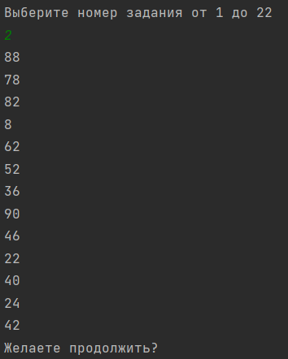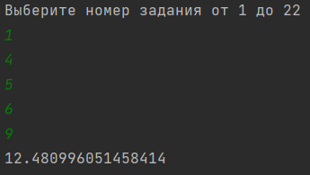**Результат программы:**

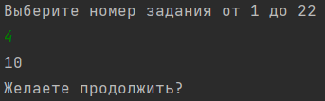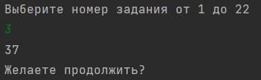

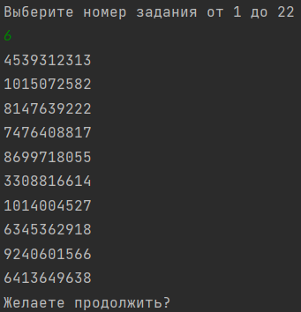

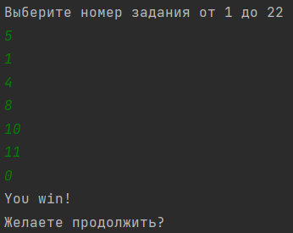

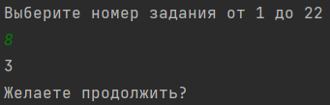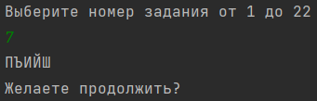

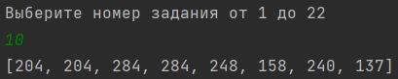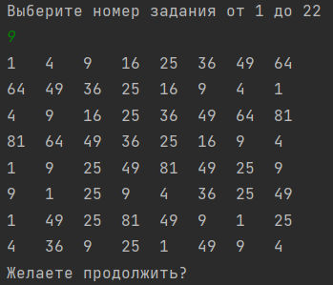





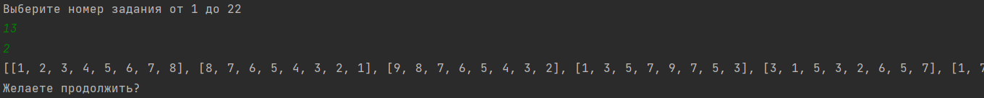  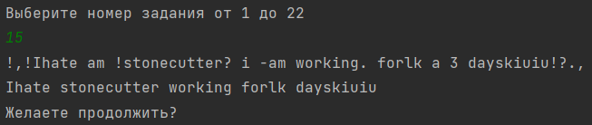 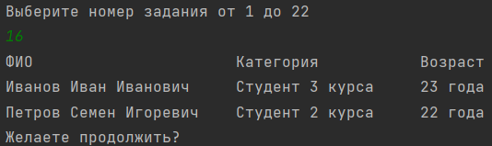 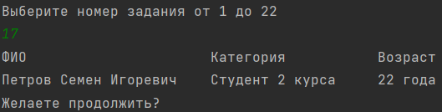

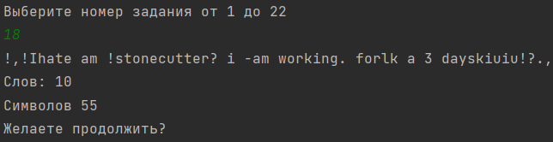

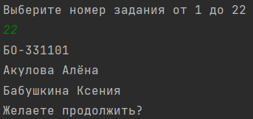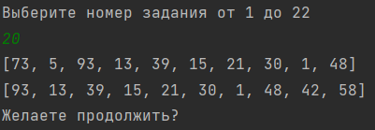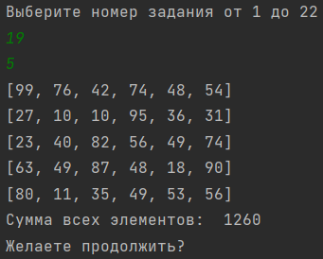 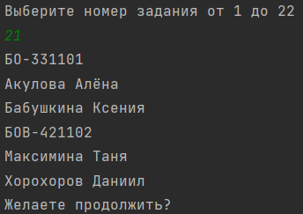

**Вывод:**

Задания выполнены согласно варианту.